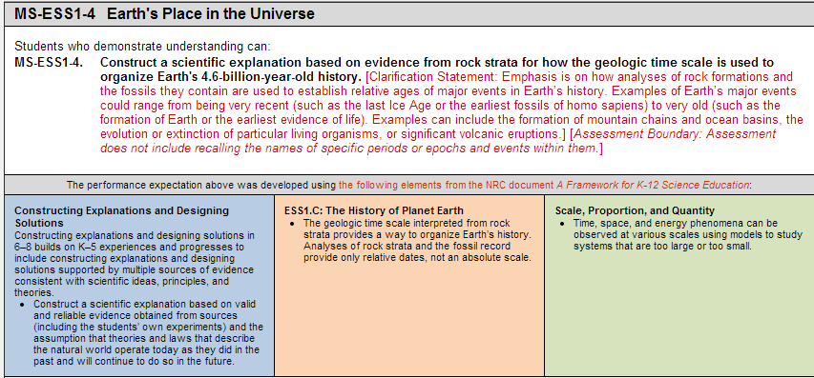
Session Reflection Sheet
Identify specific aspects of the instructional task that incorporated each of the NGSS dimensions above.
SEP |  | DCI |  | XCC
Does the lesson target align with the intent of the standard? Explain your thinking.

What connections  to the Common Core State Standards  where visible  in the lesson? | Math: |  | ELA:
Identify strengths and weaknesses of this lesson.

What modifications would you make to address the weakness, if any, of this task?

What would be your next steps of instruction?

