…will improve my implementation of KCAS?  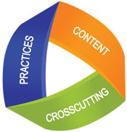 | …will improve my assessment literacy?
…will improve the effectiveness of teaching and learning in my classroom? | … will improve my capacity to lead others?
What knowledge, understandings, & skills…
Give one, Get one:
1. Find a ‘perfect match’:
Name: __________________________district:_______________________
& compare knowledge, skills & understanding for KCAS.

2. Find a ‘perfect stranger’:
Name: ___________________________district:______________________
& compare knowledge, skills & understanding for Assessment Literacy.

3. Form a ‘perfect team’ - join another pair:
Name: ___________________________ district: _____________________
Name: ___________________________ district: _____________________
& compare Highly Effective Teaching and Learning.

